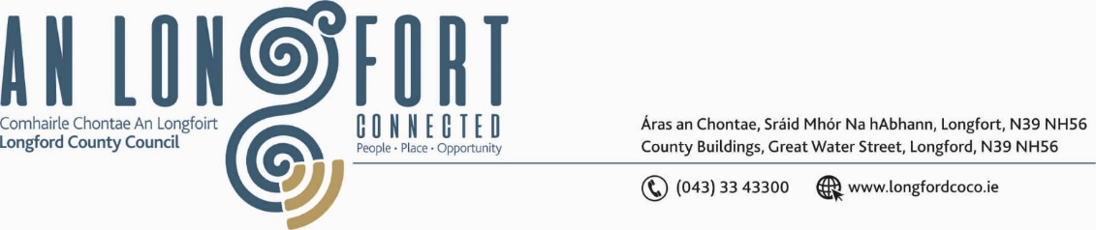

**GRANARD MUNICIPAL DISTRICT**

***Please note meeting will be held via Microsoft Teams.***

**19January 2022.**

**To: Each Member of Granard Municipal District.**

**Dear Member,**

You are requested to attend a Meeting of Granard Municipal District to be held

**via Microsoft Teams** on **Tuesday 25 January 2022 at 3.30pm** to transact business, as set out on the Agenda hereunder.

**Yours sincerely**,

Ann Marie Mc Keon

______________________

**Ann Marie Mc Keon,**

**Meetings Administrator.**

**AGENDA**

Prayer before meeting.

**1.** Confirmation of Minutes as follows: -

* Granard Municipal District Meeting held on 23rd November 2021 – copy enclosed.

**2.** Matters arising from Minutes.

**3.** Declaration of Interest by Members.

**4.** Management Report incorporating Area Engineer’s Progress Report - enclosed.

**5.** Presentation on Age Friendly Healthy Homes Programme.

**6.** Proposed Projects/Expression of interest – enclosed.

**7.** Update from the Heritage Officer on projects in Granard Municipal District.

**8.** Consideration of BCP costs under the GMA 2022.

**9**. Consideration and adoption of Draft Municipal District Report for inclusion in

Longford County Council 2021 Annual Report – enclosed.

**10.** Consideration of one Nominee for each of the 2020/2021 and 2021/2022 Cathaoirleach Awards.

**11. Notices of Motions, submitted by Councillors, as listed hereunder –**

**Councillor Turlough Mc Govern**

(i) “I call on Longford County council and Irish water to up-grade the existing pipes at the Granard Reservoir, that have caused a water outage in the Granard area, with serious disruption to households, twice a month for the last year”.

(ii) “I call on Longford County Council to up-grade the N55 road from Granard to Edgeworthstown at Tonywarden as there is considerable safety concerns arising from this part of the road, a serious dip and structural damage with surface defects and that the presence of such defects has increased the frequency of road collisions on this part of the road”.

(iii) Is there any up-date on whether Longford County Council or Tuaith are taking over Colmcille Terrace?